Lab 03 - .NET - Dev – Performing Automated Deployments for Azure Kubernetes Service
Estimated duration: 20 minutes
Lab Type: Instructor Led
Objective:
In this lab, we will learn how to automatically containerize and deploy an application into AKS.
Introduction:
Automated deployments simplify the process of setting up a GitHub Action and creating an automated pipeline for your code releases to your Azure Kubernetes Service (AKS) cluster. Once connected, every new commit will kick off the pipeline, resulting in your application being updated. We have already seen how to enable continuous deployment using Github Actions in Lab 1. In line with that, we will see how to do it for an AKS.
There are two options in the Automated deployments.
- Automatically containerize and deploy - If you have an application that isn't yet containerized, you can select Automatically containerize and deploy to allow Azure to take care of the process for you.
- Deploy an application - If you already have a containerized application, select Deploy an application
There are two options in the Automated deployments.
- Automatically containerize and deploy - If you have an application that isn't yet containerized, you can select Automatically containerize and deploy to allow Azure to take care of the process for you.
- Deploy an application - If you already have a containerized application, select Deploy an application

Exercise 1: Create an AKS Cluster
- Login to Azure portal at https://portal.azure.com
- Type in Azure Kubernetes service in the search bar and select Azure Kubernetes Service(AKS) from under Marketplace.
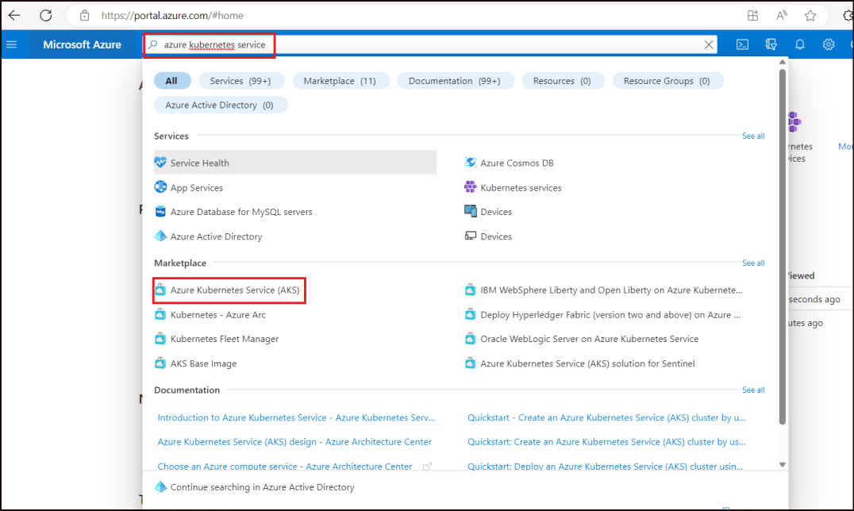
- Click on Create.
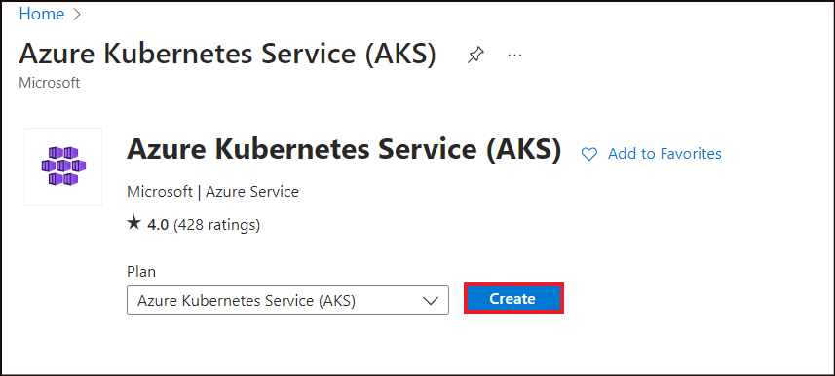
- On the Create Kubernetes cluster page, enter the below details.
Property | Value
Resource Group | Create new -> Enter the name as RGForAppService
- 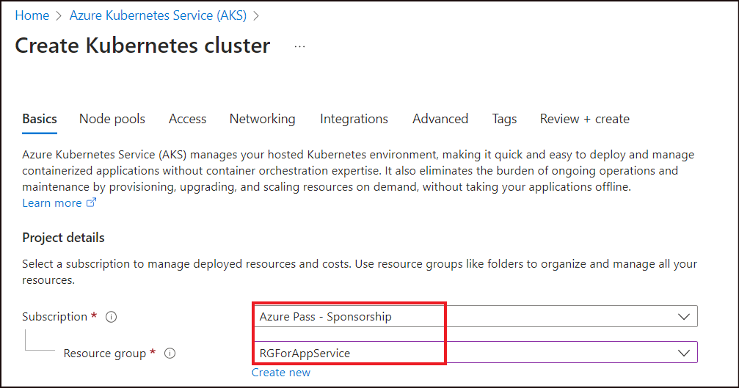
- Under Cluster details, enter the following and then click on Review + create.
Property | Value
Cluster preset configuration | Dev/Test
Kubernetes cluster name | AKScluster
Region | East US
Availability zone | None
AKS Pricing tier | Free
Kubernetes version | 1.26.6(default)
Automatic update | Enabled with patch
Authentication and Authorization | Local accounts with Kubernetes RBAC
- 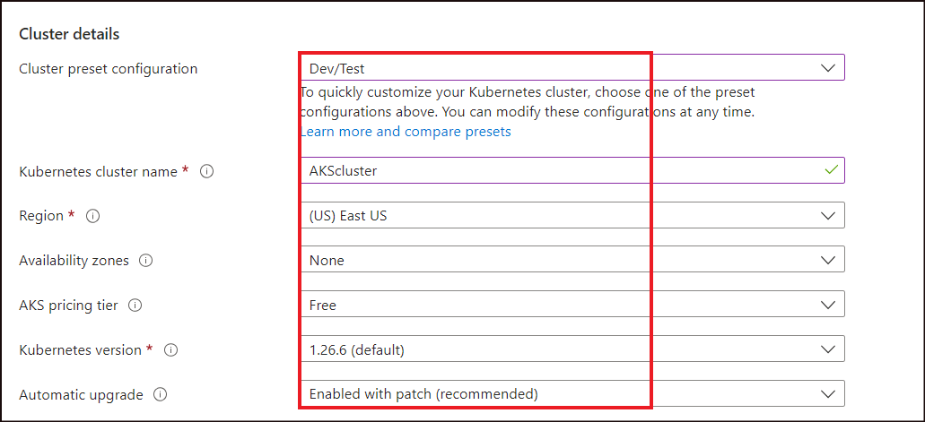
- 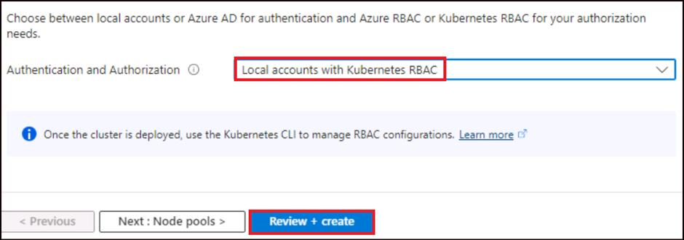
- Once the validation passes, click on Create to create the cluster.
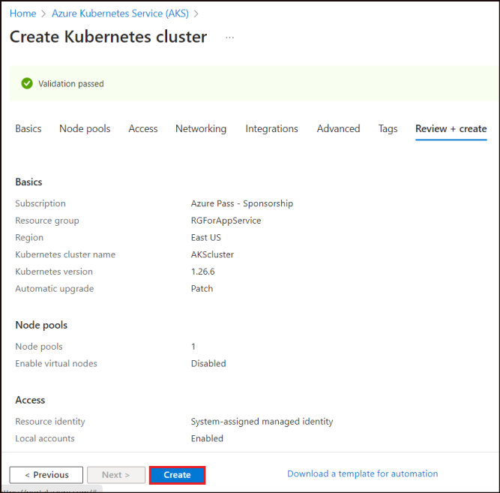
- Once the cluster is created, click on Go to resource.
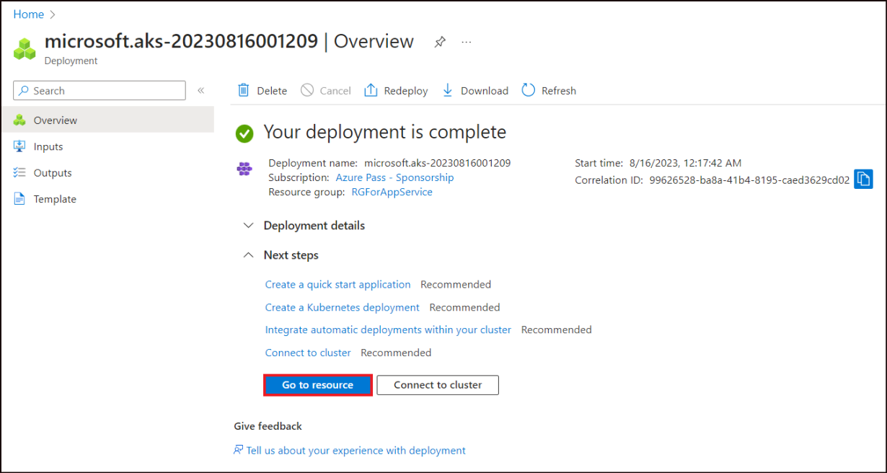

Exercise 2: Configure an automated deployment
- From the left pane of the AKS cluster page, select Automated deployments (preview).
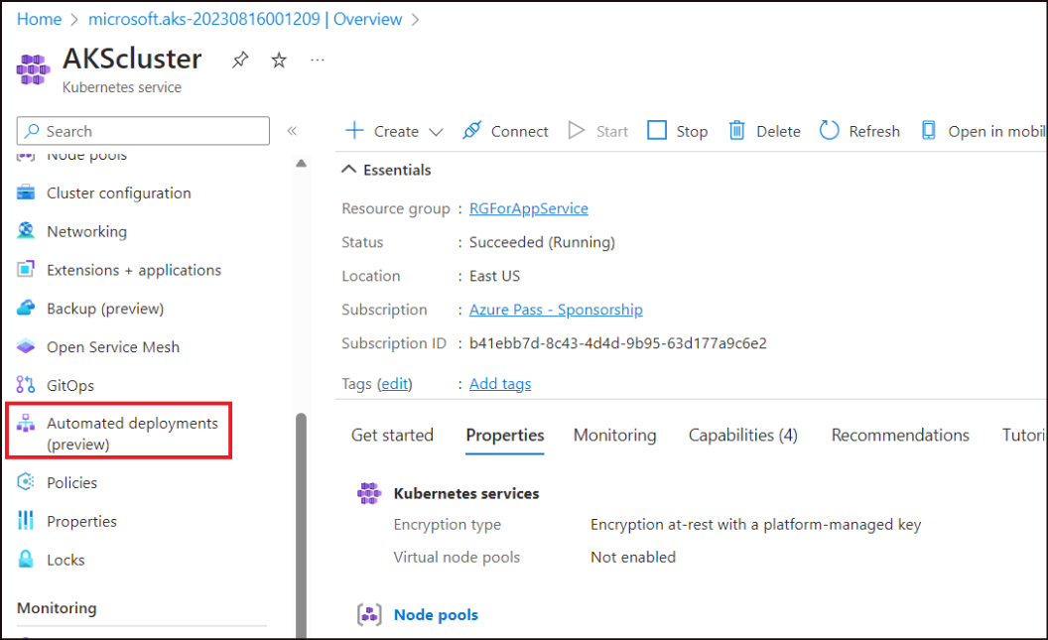
- Click on the drop down next to Create and select Automatically containerize and deploy.
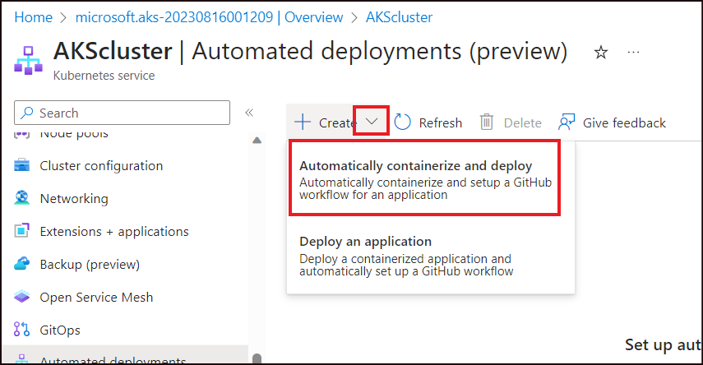
- On the Automatically containerize and deploy screen, enter the following details
Property | Value
Workflow name | autodeployXX (Replace XX with a randome number)
Repository location | Click on Authorize access and sign in to your GitHub account. (If Authorized already, your GitHub account will already be listed there). If already logged in, skip the step 4 and proceed with 5.
- 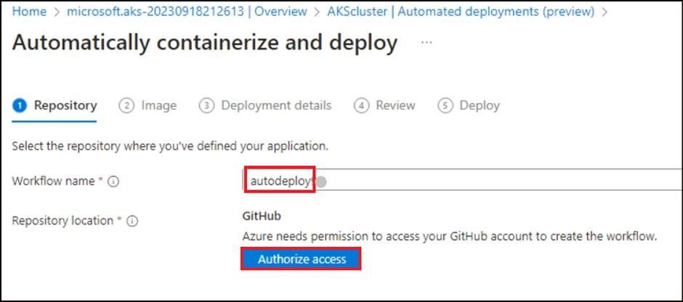
- Click on Authorize k8-extensions.
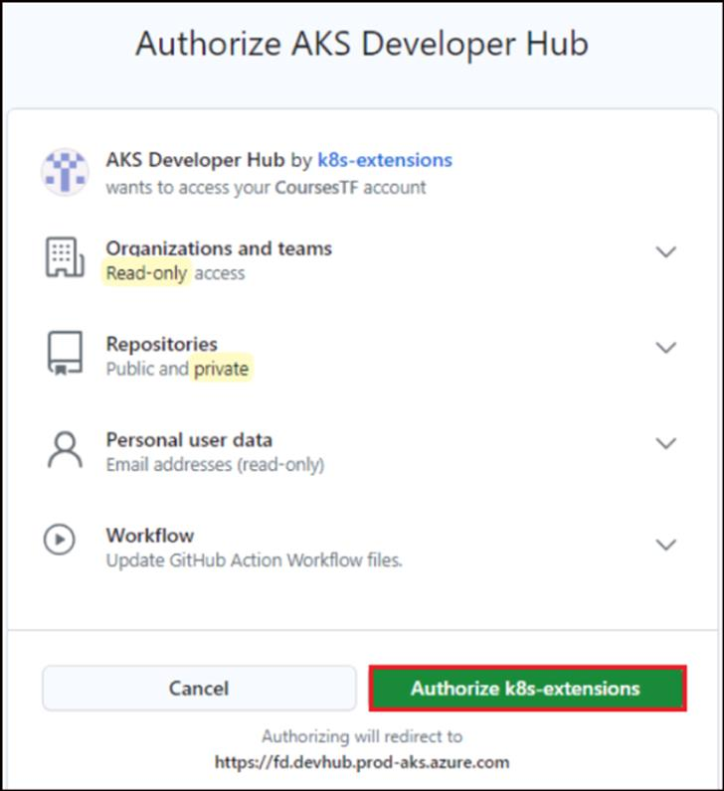
- Add the remaining details and click on Next: Image
Property | Value
Repository source | My repositories
Repository | dotnet-core-api
Branch | master
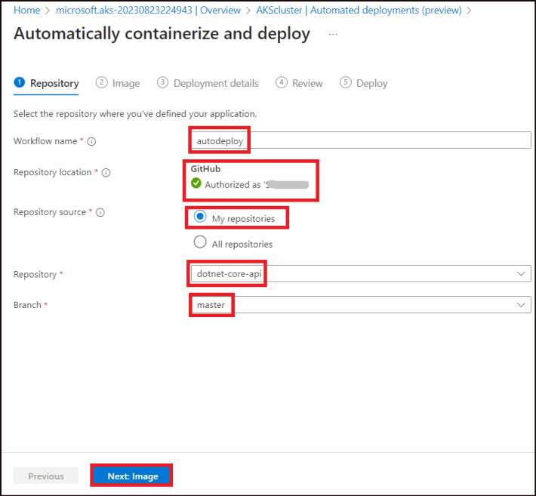
- On the Image tab, ensure ensure that the Application environment is selected as C# - 7.0
Accept the defaults and select, Next: Deployment details.
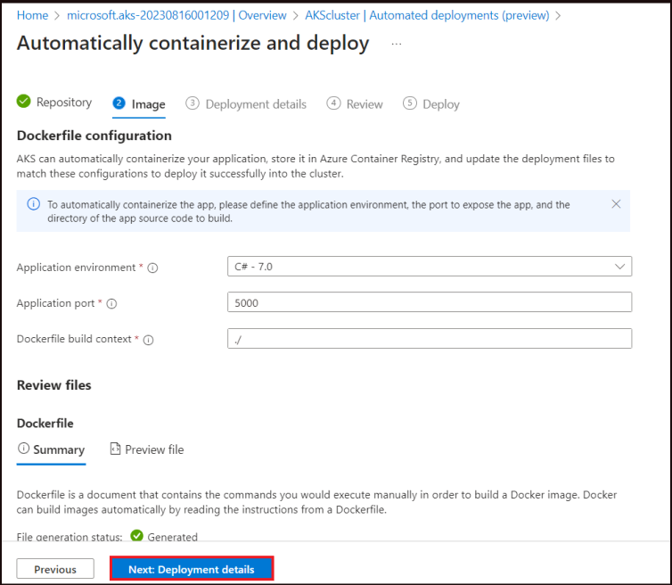
- Here, we can see that the deployment.yaml and the service.yaml files are generated. Click on Next: Review
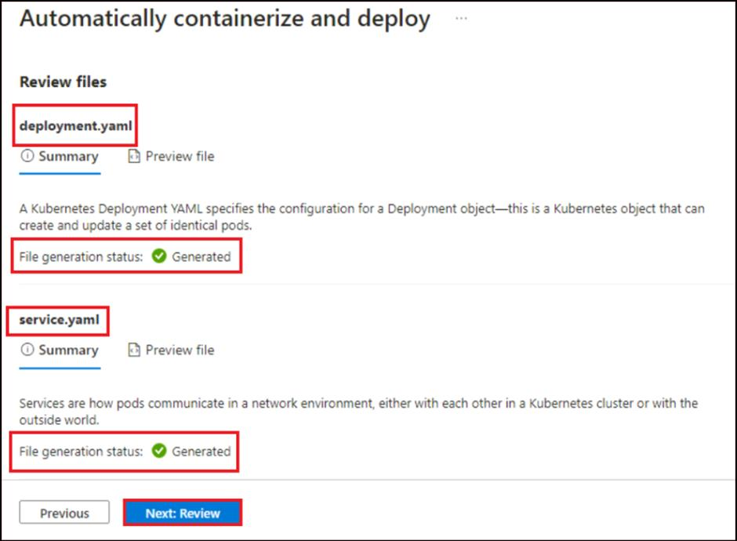
- Validate the details and then click on Next: Deploy
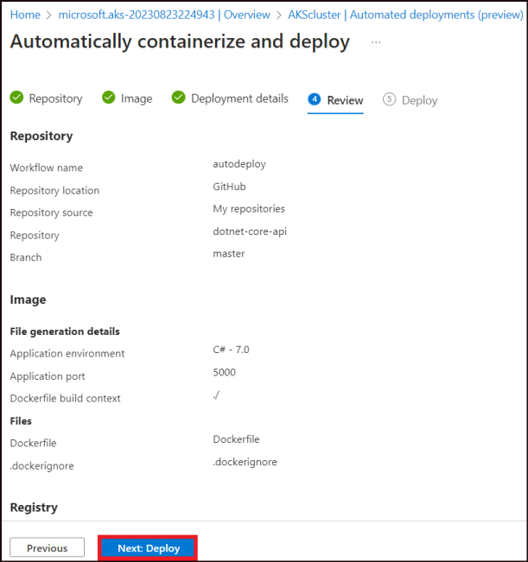
- On the next screen, check if the Pull request was successfully created and then click on Approve pull request.
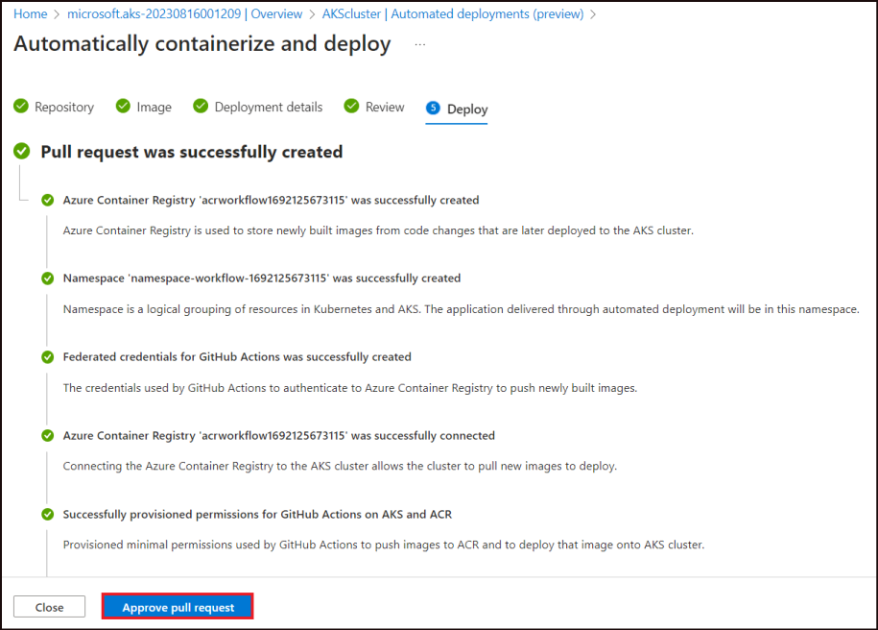
- Click on Merge pull request.
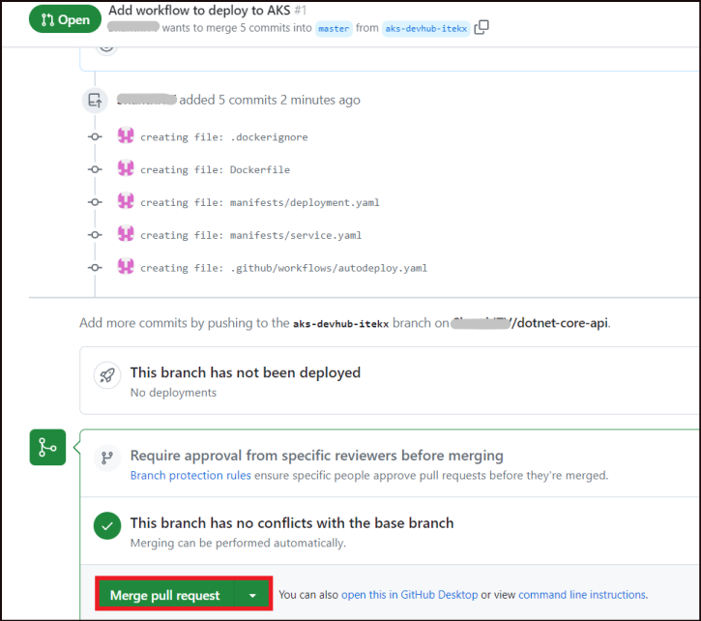
- Click on Confirm merge.
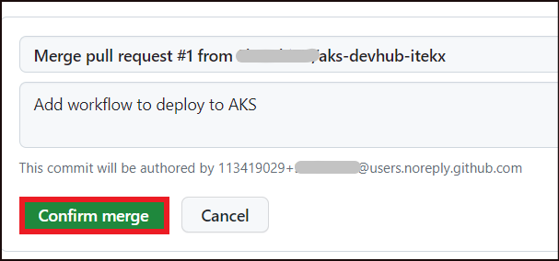
- Back in the Azure portal, click on the Automated deployments(preview) option from the left pane of the AKScluster page. Check that the workflow has succeeded. Click on the workflow name(autodeploy).
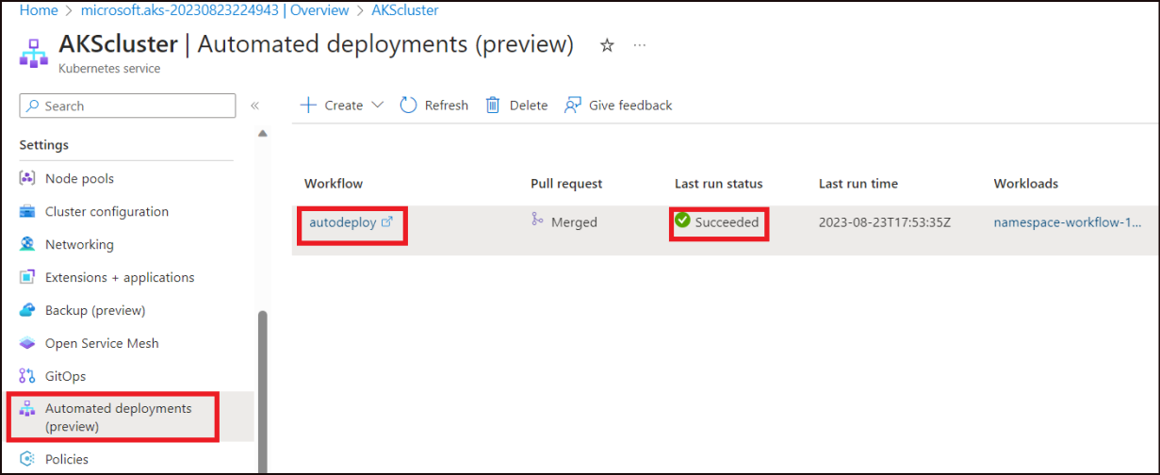
- It will take you to the workflow page in GitHub.
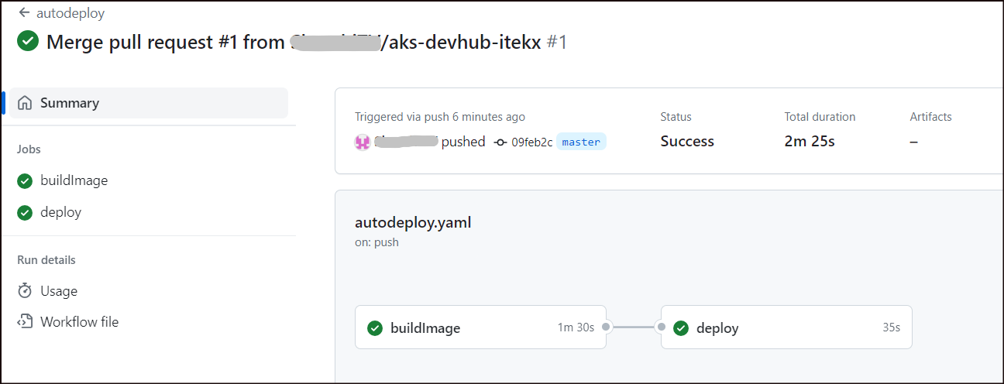
- Open the buildimage and the deploy components of the workflow to explore the deployment details.

Exercise 3: Access the application
- Back in the Azure portal, from the left pane of the AKSCluster page , select Namespaces under Kubernetes resources. We could find the namespace that we had mentioned during the deployment.
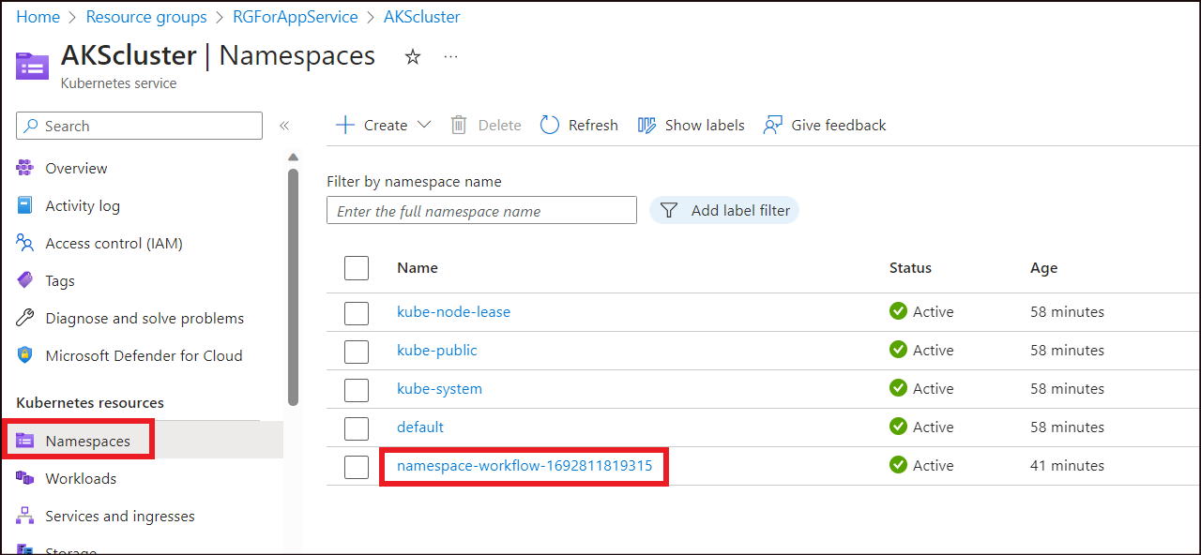
- Select Workloads from the left pane. We could find that the autodeploy deployment is listed over there.
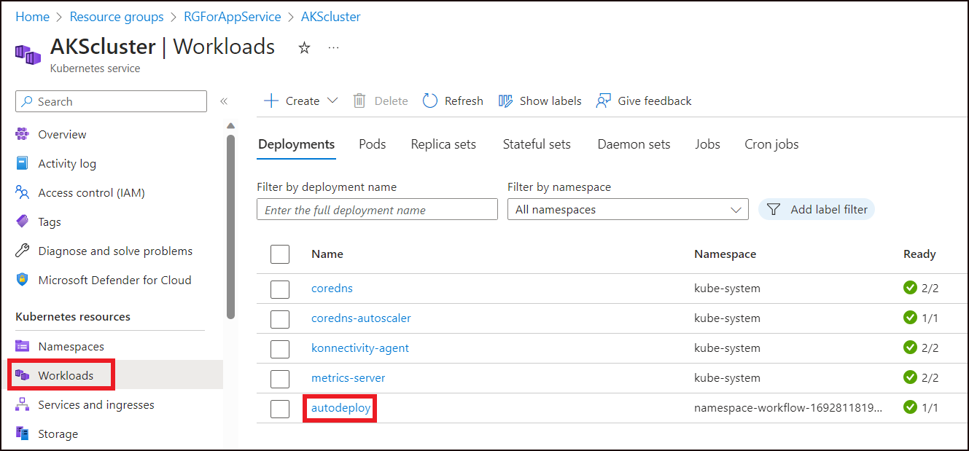
- From the left pane, now select the Services and ingresses option.
- The External IP for the application is listed here. Click on the IPaddress listed under External IP. 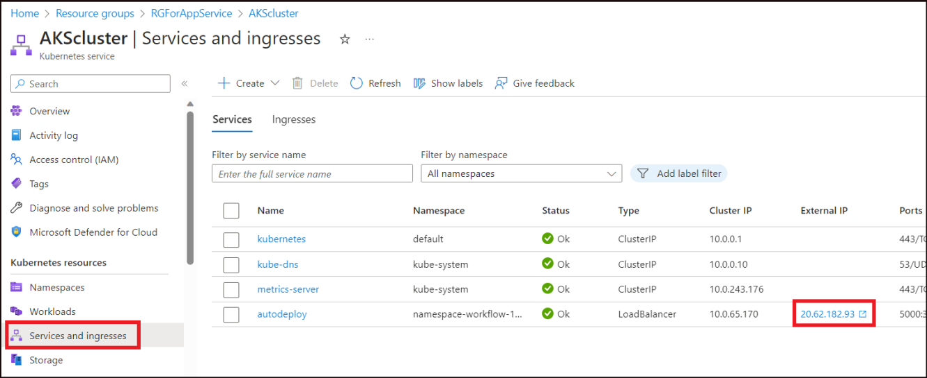
- The Todo List app gets opened in the browser.
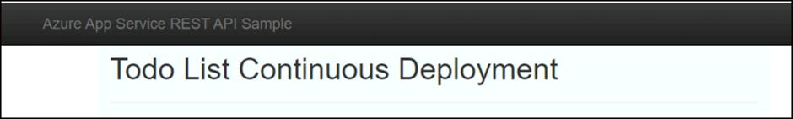

Exercise 4: Clean up resources
- From the Azure portal, click on the Resource group RGForAppService and click on Delete Resource group.
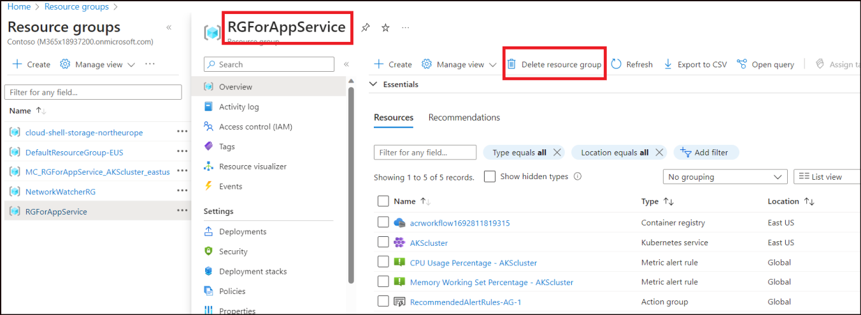
- Type in the RGForAppService in the text box and then click on Delete.
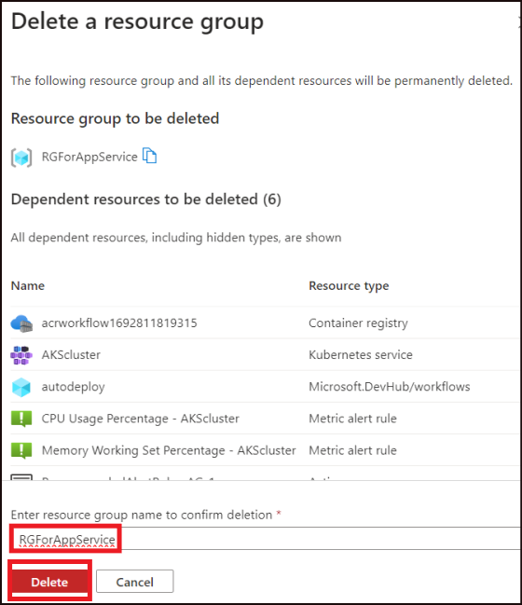
- Click on Delete in the confirmation dialog.
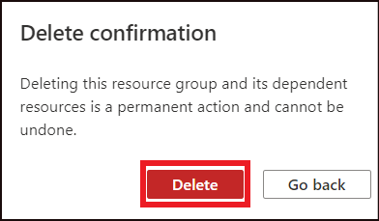
- A success message is displayed once the deletion has succeeded.
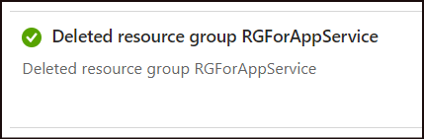
Summary
In this lab, you have successfully learnt on how to perform Automated Deployments for Azure Kubernetes Service.

